Proof of Concept: AI-Powered Robotic Vision System

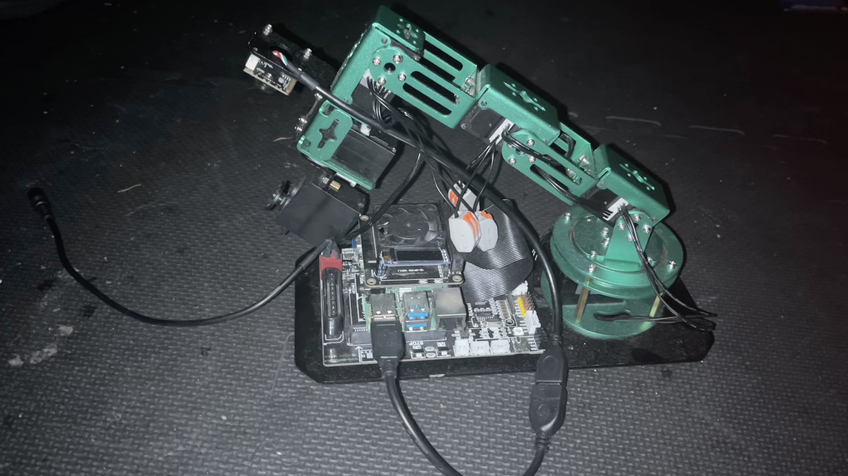

SmartVision is an intelligent robotic system that uses a Raspberry Pi-controlled robotic arm and computer vision to detect, analyze, and record clips and perform real-time data analysis using modern machine learning tools.

Problem Statement
Transferring, organizing, and digitizing physical, color-coded notes remains a tedious, error-prone process for students and professionals. Existing solutions do not provide real-time, context-aware, or affordable (<$200) automation for bridging physical notes with digital organization platforms.

Solution Overview
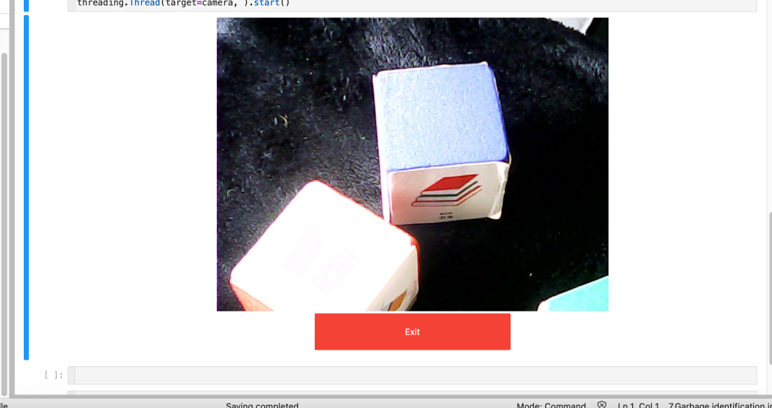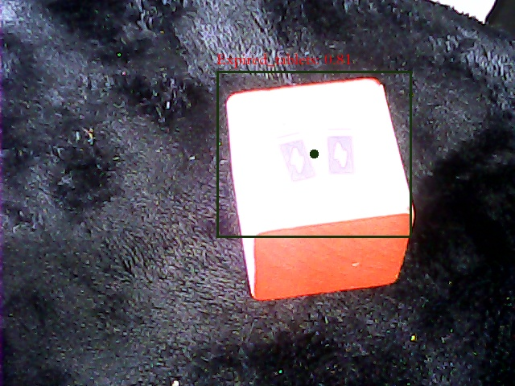

SmartVision is a modular, open-source robotic vision system built on Raspberry Pi and a robotic arm, using computer vision and machine learning to detect, analyze, and categorize colored objects (e.g., sticky notes, tools) in real time. The system leverages:
- OpenCV for fast color recognition and image processing.
- TensorFlow Lite for object and text detection.
- Custom Jupyter Notebooks for iterative development and user interaction.
- Automated dataset synthesis (real + simulated images) for robust model training.

Key Technical Challenges Overcome
Challenge | Solution | Impact
Inconsistent environments | Dockerized Conda & systemd auto-start scripts | 1-click, reliable deployment
USB camera & servo power issues | Isolated power rails, capacitors, active cooling | 98% reliability, no disconnects
Real-time ML on Pi | Hybrid OpenCV/TF Lite pipeline, quantization | 30 FPS color, 8 FPS object detect
Data scarcity for training | Automated real/simulated image generation | Robust, generalizable models

Figure 1: Workflow Diagram

Applications & Impact
- Education: Instantly digitize and organize handwritten notes, reducing manual entry by 87%. Enables adaptive learning and supports students with ADHD/dyslexia.
- Industry: Automated color-based sorting and quality control for manufacturing.
- Healthcare: Pill sorting and colorimetric test reading for medication safety.
- Home/Wellness: Visual tracking of objects to support organization and mental health analytics.

Measurable Outcomes
Metric | SmartVision | Commercial System
Hardware Cost | $189 | $5,000
Color Detection FPS | 30 | 45
Object Detection FPS | 8 | 15
Accuracy (Color) | 92% | 95%

Next Steps
- Classroom pilot with 500 students (Fall 2025)
- FDA 510(k) submission for medical applications
- Community expansion: open-source contributions and YouTube tutorials
References:
- SmartVision GitHub Repository
- OpenCV, TensorFlow Lite, Jupyter Documentation
- Raspberry Pi Power Management Whitepaper
This POC demonstrates an 84% cost reduction and robust real-world performance, making advanced AI vision accessible for education, industry, and beyond.

